**Illustrating reaction rate graphically and interpret experimental data**

Experiment to measure rate of reaction of magnesium and hydrochloric acid.

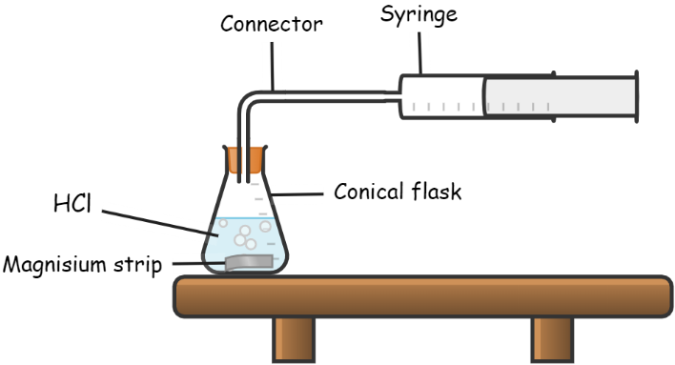

Procedure

1. Place 100cm3 of 0.5M hydrochloric acid in a conical flask.
2. Drop a piece of clean magnesium strip into the acid in the conical flask, immediately stopper the flask and start a stopwatch.
3. Collect the gas evolved in a graduated syringe.
4. Record the volume of the gas every 30 seconds for about 5 minutes.

Results

|  |  |  |  |  |  |  |  |  |
| --- | --- | --- | --- | --- | --- | --- | --- | --- |
| Time in seconds | 0 | 10 | 20 | 30 | 40 | 50 | 60 | 70 |
| Volume of gas in cm3 | 0 | 24 | 38 | 48 | 52 | 53 | 53 | 53 |

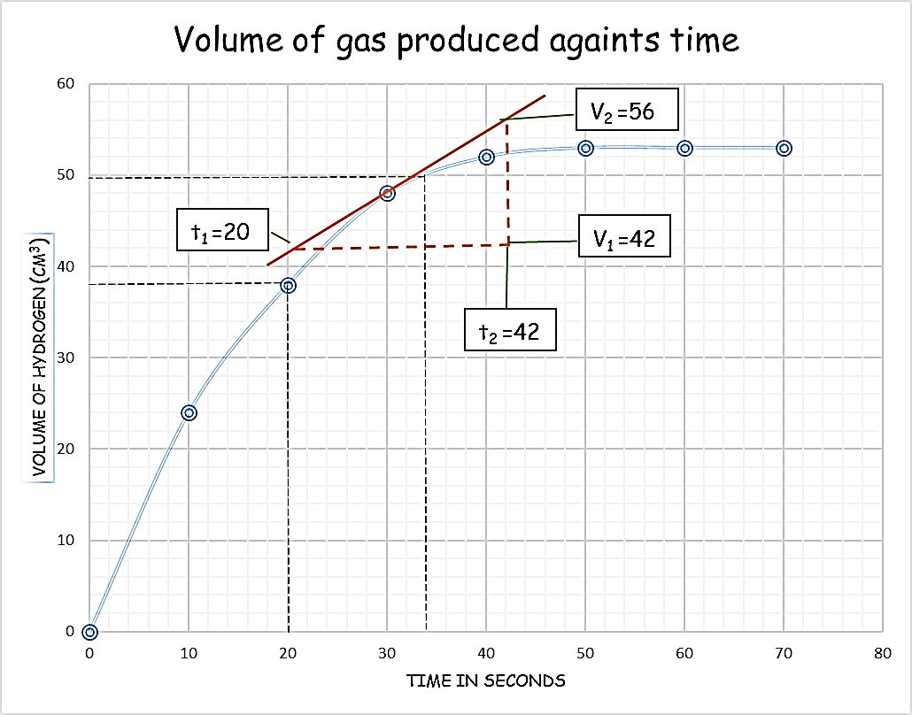

Description of the shape of the graph

* The graph is *steeper at the start* when concentration of both reactants is high.
* It is clear that as the reaction progresses, a lower volume of hydrogen gas is liberated. Both the amount of magnesium and the concentration of the acid are decreasing during the experiment. The graph *becomes less steep*.
* The reaction slows down and eventually stops when one or all the reactants are used up. The graph *becomes horizontal*.

Calculating reaction rate

Use the graph to calculate:

1. Average rate of gas produce between 20-34 sec.
2. Rate of reaction at t= 30

Solution

1. Average rate of reaction = $\frac{Volume of hyrogen produced}{time taken}$

= $\frac{V2-V1}{t2-t1}$

$\frac{50-38}{34-20}$ = 0.857 cm3/sec

1. Average rate of reaction at t=30.

Draw a tangent at the point t=30 on the graph line.

Find the gradient of the tangent at the point.

=

== 0.63 cm3/sec